***E.coli* Energy Subsystem**

The main method by which energy is generated in *E.coli* is by coupling the flow of electrons in membranes to the creation of a membrane-based proton-motive force. This proton-motive force is used by ATP synthase (ATPS4rpp) to convert adenosine diphosphate (adp_c ) to adenosine triphosphate (atp_c). In *E.coli* the electrons flow from primary electron donors to terminal electron acceptors through a series of electron carrier proteins and a class of lipids called quinones that are located in the lipid phase of the membrane (in the models to be discussed they are located in the cytoplasmic space).

A shown in Figure 1 the basic structure of the electron transport chain includes the electron donors, dehydrogenases, a quinone pool, oxidases/reductases, and electron acceptor. The electron donors are low electrode potential metabolites that can transfer their electrons to a dehydrogenase with a high electrode potential. The electrons are then transferred to quinone that have a higher electrode potential than the dehydrogenases. The electrons are then transferred to either a higher electrode potential oxidase (aerobic) or a reductase (anaerobic). The final step is to transfer the electrons to the electron acceptors which will have higher electrode potentials than the oxidases/reductases. In this final step, some but not all of the oxidases/reductase serve as proton pumps that create the proton-motive force required for ATP synthase to convert adp_c to atp_c.

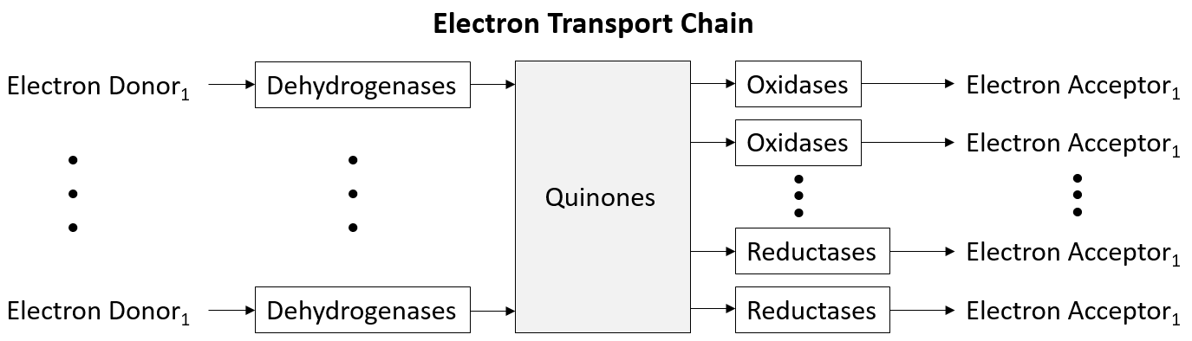

**Figure 1.** Electron transport chain

There are three different types of quinones present in *E.coli*, they include; **ubiquinone**, **menaquinone**, and **demethylmenaquinone**. The ubiquinone pools include ubiquinone-8 (q8_c) and a reduced version called ubiquinol-8 (q8h2_c) which carries the two extra electrons and protons. The menaquinone pool include menaquinone- 8 (mqn8_c) and its reduced version menaquinol-8 (mql8_c). Finally, the demethylmenaquinone pool include 2-Demethylmenaquinone 8 (2dmmq8_c) and the reduced version 2-Demethylmenaquinol 8 (2dmmql8_c). Experimentally, it has been shown that under aerobic conditions the ratio of quinones is 60% ubiquinone, 3% menaquinone, and 37% demethylmenaquinone. For anaerobic growth on nitrate the ratio is 0% ubiquinone, 30% menaquinone, and 70% demethylmenaquinone. For anaerobic growth on fumerate or DMSO the ratio is 10% ubiquinone, 70% menaquinone, and 16% demethylmenaquinone.[1]

The primary electrons donors in *E.coli* include; nicotinamide adenine dinucleotide – reduced (nadh_c), nicotinamide adenine dinucleotide phosphate – reduced (nadph_c) , formate (for_p), succinate (succ_c), pyruvate (pyr_c) , D-Lactate (lac__D_c), L-Lactate (lac__L_c), glycerol 3-phosphate (glyc3p_c), and hydrogen (h2_c). These electron donors interact with a dehydrogenase complex which removes electrons and starts them on a path through the electron transport chain.

The dehydrogenases and other reactions that interact with the quinone pool that are found in the *E.coli* models are shown below. This includes all reactions interacting with the quinone pools since these reactions can either reduce or oxidize quinone metabolites changing the pool creating an impact to the energy producing capabilities of the electron transfer chain.

|  |  |  |
| --- | --- | --- |
| **Ubiquinone Dehydrogenases** | |  |
| ***Electron Donor*** | ***Reactions*** | ***Reaction Names*** |
| dhor__S_c | DHORD2 | Dihydoorotic acid dehydrogenase (quinone8) |
| for_p | FDH4pp | Formate dehydrogenase (quinone-8) (periplasm) |
| glyc3p_c | G3PD5 | Glycerol-3-phosphate dehydrogenase (ubiquinone-8) |
| glc__D_p | GLCDpp | Glucose dehydrogenase (ubiquinone-8 as acceptor) (periplasm) |
| glyclt_c | GLYCTO2 | Glycolate oxidase |
| h2_c | HYD1pp | Hydrogenase (ubiquinone-8: 2 protons) (periplasm) |
| lac__L_c | L_LACD2 | L-Lactate dehydrogenase (ubiquinone) |
| lac__D_c | LDH_D2 | D-lactate dehydrogenase |
| mal__L_c | MDH2 | Malate dehydrogenase (ubiquinone 8 as acceptor) |
| nadh_c | NADH16pp | NADH dehydrogenase (ubiquinone-8 & 3 protons) (periplasm) |
| nadh_c | NADH5 | NADH dehydrogenase (ubiquinone-8 ) |
| nadph_c | NADPHQR2 | NADPH Quinone reductase (Ubiquinone-8) |
| pyr_c | POX | Pyruvate oxidase |
| succ_c | SUCDi | Succinate dehydrogenase (irreversible) |
|  |  |  |
| **Menaquinone Dehydrogenases** | |  |
| ***Electron Donor*** | ***Reactions*** | ***Reaction Names*** |
| for_p | FDH5pp | Formate Dehydrogenase (menaquinone-8) (periplasm) |
| dhor__S_c | DHORD5 | Dihydroorotic acid (menaquinone-8) |
| glyc3p_c | G3PD6 | Glycerol-3-phosphate dehydrogenase (menaquinone-8) |
| glyclt_c | GLYCTO3 | Glycolate oxidase |
| h2_c | HYD2pp | Hydrogenase (menaquinone8: 2 protons) (periplasm) |
| lac__L_c | L_LACD3 | L-Lactate dehydrogenase (menaquinone) |
| mal__L_c | MDH3 | Malate dehydrogenase (menaquinone 8 as acceptor) |
| nadh_c | NADH10 | NADH dehydrogenase (menaquinone-8 & 0 protons) |
| nadh_c | NADH17pp | NADH dehydrogenase (menaquinone-8 & 3 protons) (periplasm) |
| nadph_c | NADPHQR3 | NADPH Quinone Reductase (Menaquinone-8) |
|  |  |  |
| **Demethylmenaquinone Dehydrogenases** | | |
| ***Electron Donor*** | ***Reactions*** | ***Reaction Names*** |
| fum_c | FRD3 | Fumarate reductase |
| glyc3p_c | G3PD7 | Glycerol-3-phosphate dehydrogenase (demethylmenaquinone-8) |
| glyclt_c | GLYCTO4 | Glycolate oxidase |
| h2_c | HYD3pp | Hydrogenase (Demethylmenaquinone-8: 2 protons) (periplasm) |
| nadh_c | NADH18pp | NADH dehydrogenase (demethylmenaquinone-8 & 3 protons) (periplasm) |
| nadh_c | NADH9 | NADH dehydrogenase (demethylmenaquinone-8 & 0 protons) |
| nadph_c | NADPHQR4 | NADPH Quinone Reductase (2-Demethylmenaquinone-8) |

After the electrons have been transferred from the dehydrogenases to the quinones they are transferred to an oxidase or reductase and eventually to the terminal electron acceptors. The electron acceptors present in *E.coli* that are part of the cell’s energy production include; oxygen (o2_c), nitrate (no3_c), dimethyl sulfoxide (dmso_c and dmso_p), Trimethylamine N-oxide (tmao_c and tmao_p). A table showing the relationship between the electron acceptors and the oxidases and reductases is shown below.

|  |  |  |
| --- | --- | --- |
| **Ubiquinone Oxidases/Reductases** | | |
| ***Electron Acceptor*** | ***Reactions*** | ***Reaction Names*** |
| asp__L_c | ASPO3 | L-aspartate oxidase |
| o2_c | CYTBDpp | Cytochrome oxidase bd (ubiquinol-8: 2 protons) (periplasm) |
| o2_c | CYTBO3_4pp | Cytochrome oxidase bo3 (ubiquinol-8: 4 protons) (periplasm) |
| amet_c | DMQMT | 3-Dimethylubiquinonol 3-methyltransferase |
| dsbard_p | DSBAO1 | DsbA protein reoxidation reaction (aerobic) |
| no3_c | NO3R1bpp | Nitrate reductase (Ubiquinol-8) |
| no3_c | NO3R1pp | 'Nitrate reductase (Ubiquinol-8) (periplasm)' |
| no2_p | NTRIR3pp | Nitrite Reductase (Ubiquinole-8, periplasm) |
| o2_c | QMO2 | 'Quinol monooxygenase (Ubiquinol-8)' |
|  |  |  |
| **Menaquinone Oxidases/Reductases** | | |
| ***Electron Acceptor*** | ***Reactions*** | ***Reaction Names*** |
| amet_c | AMMQLT8 | S-adenosylmethione:2-demthylmenaquinole methyltransferase (menaquinone 8) |
| asp__L_c | ASPO4 | L-aspartate oxidase |
| o2_c | CYTBD2pp | Cytochrome oxidase bd (menaquinol-8: 2 protons) (periplasm) |
| dmso_c | DMSOR1 | Dimethyl sulfoxide reductase (Menaquinol 8) |
| dmso_p | DMSOR1pp | Dimethyl sulfoxide reductase (Menaquinol 8) (periplasm) |
| dsbard_p | DSBAO2 | DsbA protein reoxidation reaction (anaerobic) |
| fum_c | FRD2 | Fumarate reductase |
| no3_c | NO3R2bpp | Nitrate reductase (Menaquinol-8) (periplasm) |
| no3_c | NO3R2pp | Nitrate reductase (Menaquinol-8) (periplasm) |
| no2_c | NTRIR4pp | Nitrite Reductase (Menaquinole-8, periplasm) |
| o2_c | QMO3 | Quinol monooxygenase (menaquinol 8) |
| sel_c | SELR | Selenate reductase |
| tmao_c | TMAOR1 | Trimethylamine N-oxide reductase (menaquinol 8) |
| tmao_p | TMAOR1pp | Trimethylamine N-oxide reductase (menaquinol 8) (periplasm) |
|  |  |  |
| **Demethylmenaquinone Oxidases/Reductases** | | |
| ***Electron Acceptor*** | ***Reactions*** | ***Reaction Names*** |
| amet_c | AMMQLT8 | S-adenosylmethione:2-demthylmenaquinole methyltransferase (menaquinone 8) |
| dhna_c | DHNAOT4 | 1,4-dihydroxy-2-naphthoate octaprenyltransferase |
| dmso_c | DMSOR2 | Dimethyl sulfoxide reductase (Demethylmenaquinol 8) |
| dmso_p | DMSOR2pp | Dimethyl sulfoxide reductase (Demethylmenaquinol 8) (periplasm) |
| fum_c | FRD3 | Fumarate reductase |
| tmao_c | TMAOR2 | Trimethylamine N-oxide reductase (demethylmenaquinol 8) |
| tmao_p | TMAOR2pp | Trimethylamine N-oxide reductase (demethylmenaquinol 8) (periplasm) |

|  |
| --- |
| Below are some diagrams that visually show the relationships between the electron donors, the dehydrogenases, the quinone pools and the oxidases and reductases for the electron transport chain of *E.coli*. The first is the ubiquinone pool. These figures begin on the left by showing all the dehydrogenases and their associated electron donor available for each quinone pool. On the right is a list of all the oxidases/reductases with their electron acceptors for a given quinone pool. |
| **Figure 1.** A diagram showing the relationships between the electron donors, the dehydrogenases, the ubiquinone pool and the oxidases and reductases for the electron transport chain of *E.coli*. The enzymes that also serve as proton pumps are shown in the red.  In Figure 1, the enzymes that also serve as proton pumps are shown in the red. Oxidative phosphorylation requires that protons are pumped from the cytoplasmic to the periplasmic space to create the proton-motive force that will force ATP synthase to produce atp_c. For the dehydrogenases there are three enzymes that can pump protons from the cytoplasmic to the periplasmic space. The enzyme NADH16pp is the primary dehydrogenase used in glucose-driven aerobic conditions. For this enzyme three protons are transferred to the periplasm for every two electrons that enter the enzyme. The other two dehydrogenases are only used in specific conditions; FDH4pp transfers one proton / two electrons while HYD1pp can transfer two protons / two electrons. For the oxidases/reductases there are also three enzymes that are proton pumps: CYDBpp, CYTBO3_4pp, and NO3R1pp. For these enzymes CYDBpp and NO3R1pp transfers two protons / two electrons while CYTBO3_4pp transfers 4 protons /2 electrons.  For oxidative phosphorylation the P/O ratio (the ratio of protons pumped into the periplasmic space divided by the number of protons that re-enters the cytoplasmic space to create an atp_c) of these *E.coli* models can vary between an upper limit of 7/4 (NADH16pp & CYTBO3_4pp) and 3/4 (FDH4pp & CYDBpp). These ratios are different for both nitrate and fumarate respiration. |

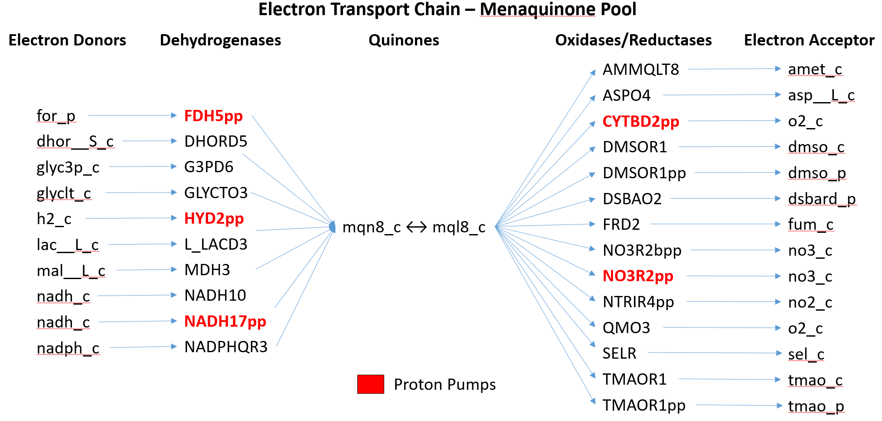

**Figure 2.** A diagram showing the relationships between the electron donors, the dehydrogenases, the menaquinone pool and the oxidases and reductases for the electron transport chain of *E.coli*. The enzymes that also serve as proton pumps are shown in the red.

In Figure 2, there are three dehydrogenases that can pump protons. The enzyme NADH17pp allows three protons to be transferred to the periplasm for every two electrons that enter the enzyme. The other two dehydrogenases are FDH5pp that can transfer one proton per two electrons while HYD2pp can transfer 2 protons / 2 electrons. For the oxidases/reductases there are also two enzymes that are proton pumps: CYTDB2pp and NO3R2pp which can both transfer 2 protons/ 2 electrons.

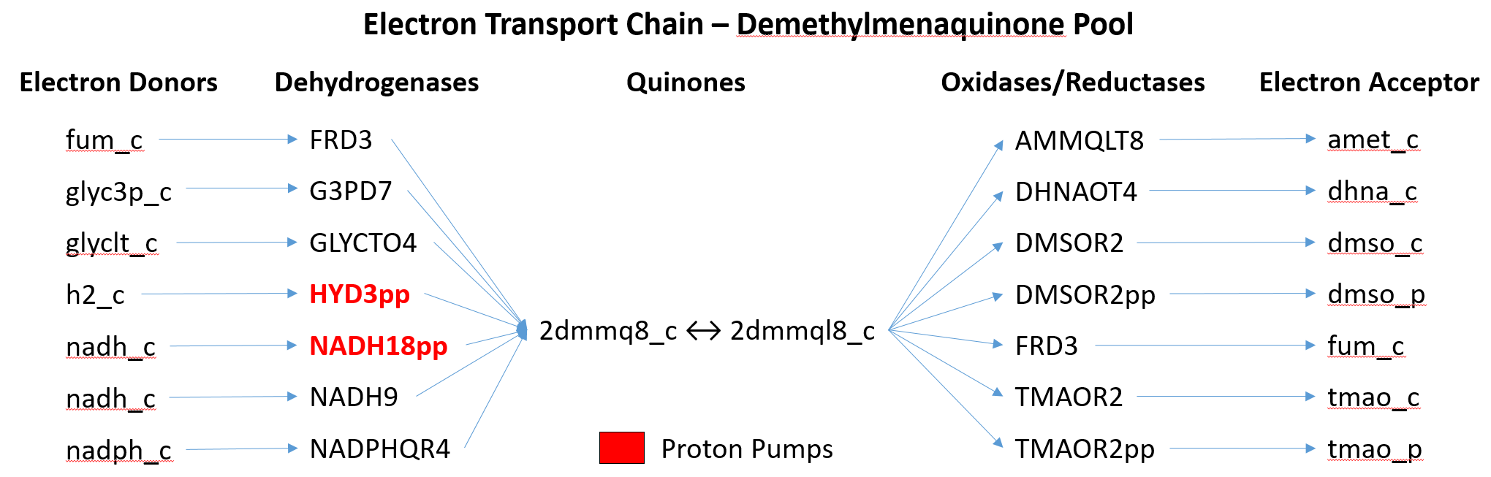

**Figure 3.** A diagram showing the relationships between the electron donors, the dehydrogenases, the demethylmenaquinone pool and the oxidases and reductases for the electron transport chain of *E.coli.* The enzymes that also serve as proton pumps are shown in the red.

In Figure 3, there are two dehydrogenases that can pump protons. The enzyme NADH18pp forces three protons to be transferred to the periplasm for every two electrons that enter the enzyme. The other dehydrogenase HYD3pp can transfer 2 protons / 2 electrons. For the oxidases/reductases there are no enzymes that are proton pumps.

[1]. D. White, “The physiology and biochemistry of prokaryotes,” Third edition, Oxford University Press, 2007.